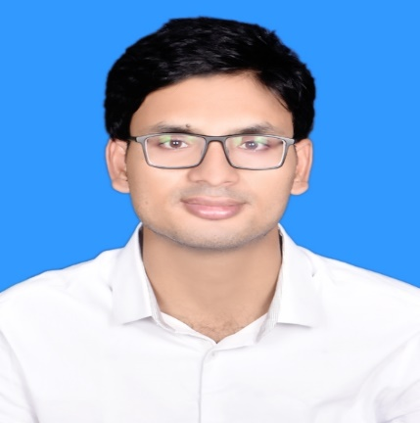

Md. Sahiqur Rahman Tipu

**CONTACTS:**

**🏠 Address:** Dhaka,Bangladesh

**📧** **E-mail:** srtipu5@gmail.com

**📞** **Phone:** +8801515268634

C:\Users\Maruf\Desktop\icons8-color-48.pngC:\Users\Maruf\Desktop\icons8-ios-filled-50.png **Github:** [github/srtipu](https://github.com/srtipu5)

**LInkdin:** [linkdin/srtipu](https://www.linkedin.com/in/sahiqur-rahman-tipu-18b548201?lipi=urn%3Ali%3Apage%3Ad_flagship3_profile_view_base_contact_details%3BPjyU1MYfSliyUCnk6rsPaw%3D%3D)

|  |  |  |  |  |  |  |  |  |
| --- | --- | --- | --- | --- | --- | --- | --- | --- |
| Technical Skills: **• Language:** C , C++ , C# , Python  **• Database:** MSSQL Server , Oracle ,  MySQL  **• Frontend:** HTML , CSS , JQuery  Javascript  **• Framework :** ASP.NET Core MVC ,  ASP.NET , Django  **Programming Skills:**  **• 450+** problems solve in [Hackerrank](https://www.hackerrank.com/srtipu5), [Uva](https://uhunt.onlinejudge.org/id/747544),  [Uri](https://www.urionlinejudge.com.br/judge/en/profile/52277),[Codeforces](https://codeforces.com/profile/sr_tipu),[Hackerearth](https://www.hackerearth.com/@md.sahiqurrahman)  **Training/Workshop:**  **•** Programming Camp-2018 organized by  ICT dept. of MBSTU.  **•** Mobile Game Development-2017  organized by ICT division.  **•** Mobile Game Graphics Design-2018  organized by ICT Division.  **Projects:**  **E-Commerce**  It is a simple web application in which I have used ASP.NET Core MVC as Backend. Bootstrap and Jquery as frontend.Here MSSQL Server database is used to store the details. I also used here Identity and Entity Framework core.  https://github.com/srtipu5/Ecommerce_Project | |  | | --- | | **Educational Qualification:**  **Bachelor of Science (BSc)** Institute: **Mawlana Bhashani Science and Technology University** Passing Year: **2020** Concentration/Major: **Information And Communication Technology (ICT)**  **Higher Secondary School Certificate (HSC)** Institute: **University Laboratory School and College** Passing Year: **2014** Concentration/Major: **Science**  **Secondary School Certificate (SSC)** Institute: **Saleha School and College** Passing Year: **2012** Concentration/Major: **Science**  **Languages Skills:**  **•** Good at Bangla & English. | |  | | **Reference**  **Dr. Arifur Rahman** Lecturer, Dhaka Dental College  Phone Number : 01716552375 Email : [dr.arif.rahman33@gmail.com](mailto:dr.arif.rahman33@gmail.com)  **Prof. Dr. Muhammad Shahin Uddin** Chairman, Dept. of ICT, MBSTUPhone Number : 01759852318Email: shahin.mbstu@gmail.com | |  | |  | |  | | |